EPI READING BADGE 2018/19
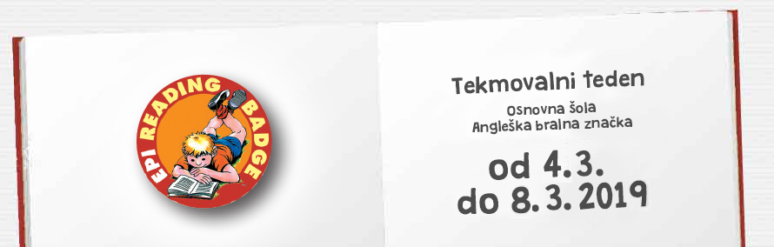
4. RAZRED
Deserts
The Enormous Turnip
We Can Help!
5. RAZRED
Beauty and the Beast
Grimlock Stops the Decepticons
Little Red Riding Hood
6. RAZRED
Michael Jordan
The Missing Coins
Great Buildings
Ice Worlds
The Talent Show
7. RAZRED
Rainbow Serpent
The Swiss Family Robinson
The Snow Queen
The Emperor and the Nightingale
The Tomorrow Mirror

8. RAZRED
American Life
Of Mice and Men
Ice Island Adventure
Journey through Arabia
James and the Giant Peach

9. RAZRED
A Scandal in Bohemia
A History of Britain
Stories of Courage
The Adventures of Huckleberry Finn
Titanic

